=Week 1 - Grasping the context

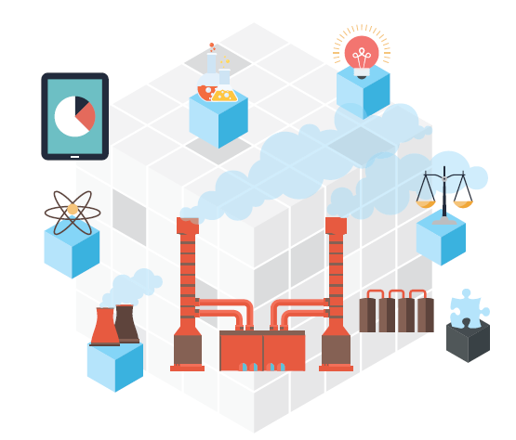

Class:

Name: Aleksandar Petrov  
Studentnumber: 3358194

Name: Gabriela Dobreva  
Studentnumber: 3356841

Date: 14-04-2016  
Version 1.1

Contents

Introduction 3

Overview assignment(s) week 1 4

The business case 5

Requirements gathering 6

Analysing the requirements 7

Visualizing the process 8

# Introduction

In Fundamentals for ICT Students (block) 2 you will work on a project that will cover all 3 streams! This week we’re going to have a look at ICT & Business and how it fits in realizing an IT solution.

One of the tasks of a ICT & Business expert is to determine what kind of business problems there are and how to solve those using IT. Besides solving a problem, finding opportunities to improve a business process (via an IT solution) is what makes you a valuable asset to the project. This skillset is also useful for non ICT & Business students/professionals.

The structure of this week’s practical will be as following:

* Read the case and discuss what the client is actually asking you to create;
* Breakdown the deliverables into requirements;
* Discuss 'weight' and prioritize the requirements.

## Overview assignment(s) week 1

**Deliverable:** This document with the answers.  
**Deliverable per**: 2 Students.  
**Deadline:** Before week 3.

As a preparation a business case is proposed. As interviewing will be covered at another course you will get a summarized transcript representing a business case. It’s up to you to determine what is really need so we don’t end up as the situation below:

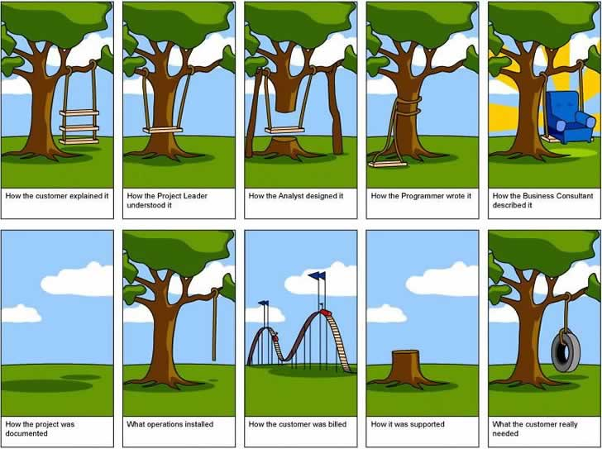

Figure 1: Project gone wrong

# The business case

Your group represents a company who is asked to implement a proof of concept for their warehouse. One of your representatives conducted an interview with the client mr. J. Doe. The following text is a summary of the transcript of the interview*:*

*I want a proof of concept to show the CEO it’s a good investment to automate a part of our warehouse logistics with an AGV following a predefined path. This proof doesn’t need to be a real AGV, but something like a robot made in Lego Mindstorms is enough.*

*I want the AGV to be able to follow a track like figure 2. It should be able to go to the pickup area to get a container and then transport it to the drop-off area to drop it off. It would be nice to have the AGV to automatically return to the start position, but we’re not sure yet how that part of the track will look like.*

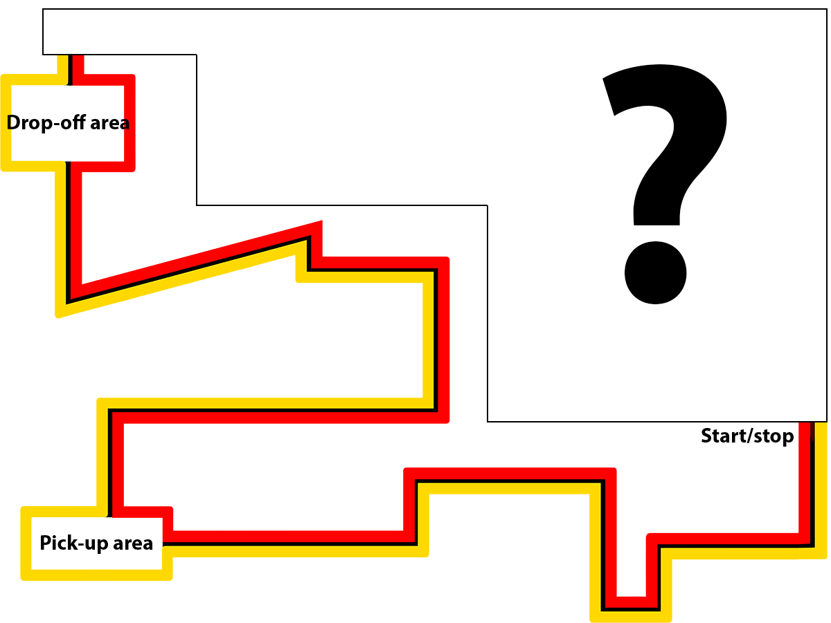

Figure 2: Predefined track though warehouse

*The actually AGV should be able to pick up a container that can weight up to 500kg. The content of the container varies per order we’re processing. It could be simple things like golf balls to heavy bowling balls. Obviously they are not as fragile as glass, but nonetheless they can be damaged if they are dropped. So it’s a bad thing if the AGV where to drive of a platform!*

*It would be nice if the AGV will be streamlined and aerodynamic minimizing the time it takes to pick-up and drop-off the container. Obviously it should not hit employees, other AGVs or machinery because of some sort of (speed) error. Some sort of emergency break is actually mandatory.*

*As mentioned we actually process different kinds of orders and it’s not set at which times the AGV should start the automated delivery. Only a packing employee knows when to start the delivery. This employee has a computer at his disposal and it would be good to see some kind of status update about what the AVG is doing. So the employee should be able to start the automated process via the predefined path, pause/resume and see the status.*

*Any extra features you can come up to convince the CEO would be greatly appreciated.*

# Requirements gathering

Mr. Doe actually had a clear view of what he wants and your representativeonly had to ask questions about some specific things like workload, exceptions, etc. Obviously in a real life situation this is not always the case.

As an ICT & Business student you will be the person who needs to communicate with the involved parties (called stakeholders) to gather the requirements. This can be done in different ways like:

* (Online) survey;
* Shadowing an employee;
* Interview;
* Etc.

The method your representative used was interviewing. Can you, based on the summary of transcript, determine what the client actually wants? Is it an AGV (look up AGV if you do not know what it is) or something else?

Discuss with each other what the actual deliverables are and what features are actually asked. Put the findings of your discussion in the table below.

Writing down per deliverable: the deliverable itself and which features are requested for it.   
**NOTE:** The features should be specified as bullet points and be specific. Something like: “it should have a remote control feature” is not good enough, but “it should have a remote control feature which can do X, Y and Z” is what is expected!

|  |  |
| --- | --- |
| Deliverable | Requested features |
| AGV robot using Lego Mindstorms EV3 | * Follow a certain predefined path by the employees. * A path which is redesignable. * Able to pick up a container. * Possible to carry up to 500kg. * Will maintain safe speed but efficient time minimizer. * Aerodynamic design. * Including emergencies breaks that keep the safety of the goods. * With wireless support. * User software for status update and control. * Weight distribution sensors. * Side laser sensors for distance measurement. * Light and Sound signal upon task completion or errors. * Phone app user interface. |

# Analysing the requirements

From a client’s perspective everything should be implemented and is important, but in reality no requirement is equal to another. As an ICT expert you will be asked to take a look at the requirements and give your opinion about how feasible (and important) it is and also judge how much time it would take to implement it.

In the coming weeks you’re actually going to prepare and at a certain point start implementing the deliverables asked by mr. Doe. Let’s have another look at the requested features and this time think about how they could be implemented.

**NOTE**: It’s really hard to think about how something needs to be implemented if you’ve never done it before. If the ‘problem’ is too big to think of a way you should try to split it up in smaller/more comprehensible pieces.

Determine with each other:

* How important it is compared to the other features;
* How much time would it take to implement compared to the other features.

Put it in the table below. Place the most important feature at the top and the least important at the bottom. In the column ‘*Implementation time (%)*’ write down what percentage of your time would go into implementing it.

|  |  |  |
| --- | --- | --- |
| Deliverable | Requested features | Implementation time (%) |
| Redesignable Colored Path  Pick Up System  Emergency Breaks  Speed Limiter  User Software Control  Weight Distribution Sensors  Distance Measurment  Wireless Support  Phone app connection.  Light and Sound | Follow a certain predefined path by the employees and can be redesigned  Able to pick up a container up to 500kg  Emergencies breaks that keep the safety of the goods  Will maintain safe speed but efficient time minimizer  User software for status update and control  Distribution of weight depending on instant calculations.  Side laser sensors for distance measurement.  Able to connect to a network.  Allows control users interaction with the AGV.  Support signalization upon task completion or errors. | 7%  13%  14%  8%  11%  15%  7%  7%  10%  8% |

# Visualizing the process

You should now have a good idea of what needs to be created and have written it down in text. As the phrase ‘a picture is worth a thousand words’ indicate, a visualization makes things easier to grasp.

There are actually different ways of visualizing text. Depending on what you want to visualize it could be a comic or perhaps an awesome drawing of an AGV.

With this last assignment you need to visualize the steps/processes that the proof of concept need to take for the automated delivery process of a container. In practice professions tend to make (business) process diagrams/models to visualize how a process works. If you search for this term you will see different examples like:

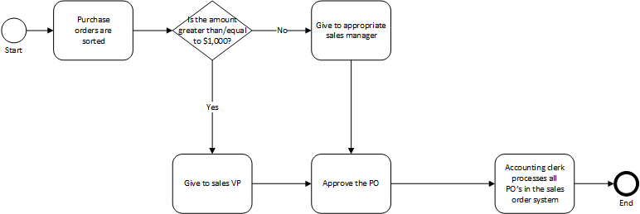

Figure 3: Example business process diagram 1

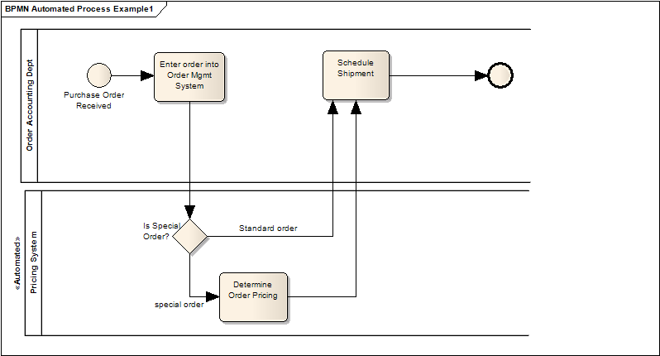

Figure 4: Example business process diagram 2

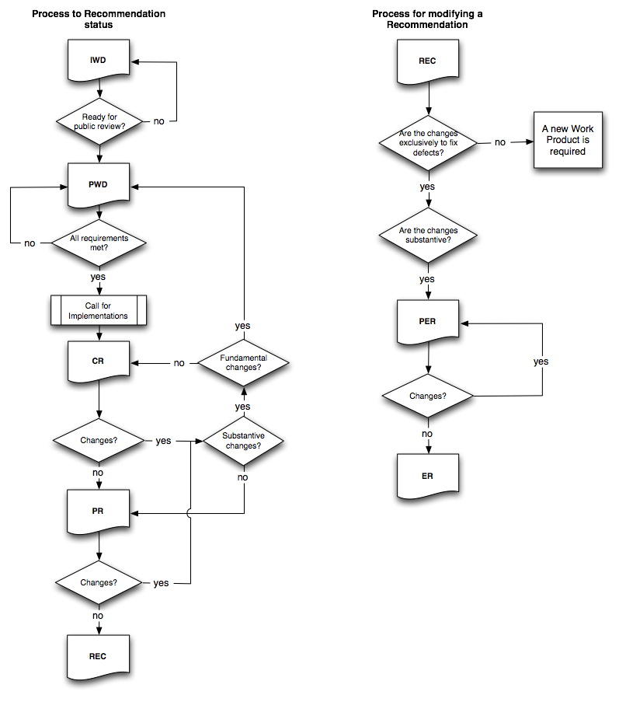As you can see there are some variations of visualizing processes, but they all have common denominators. The diagrams are all visualized as a flow chart/decision tree containing the following elements:

Figure 5: Example business process diagram 3

* Start & end point(s);
* Arrows indicating the flow/order;
* Steps/blocks in the process;
* Decision points;

Depending on the stream you choose you will get more theory about how such diagram needs to be created. For now you can decide together which way you prefer.

On the next page you can find an area where you can draw or include an image/photo for the visualization you created about the delivery process.

|  |
| --- |
|  |